ME218A Lab1 Pei-Chen Wu

Part1: Small Signal NPN Transistors

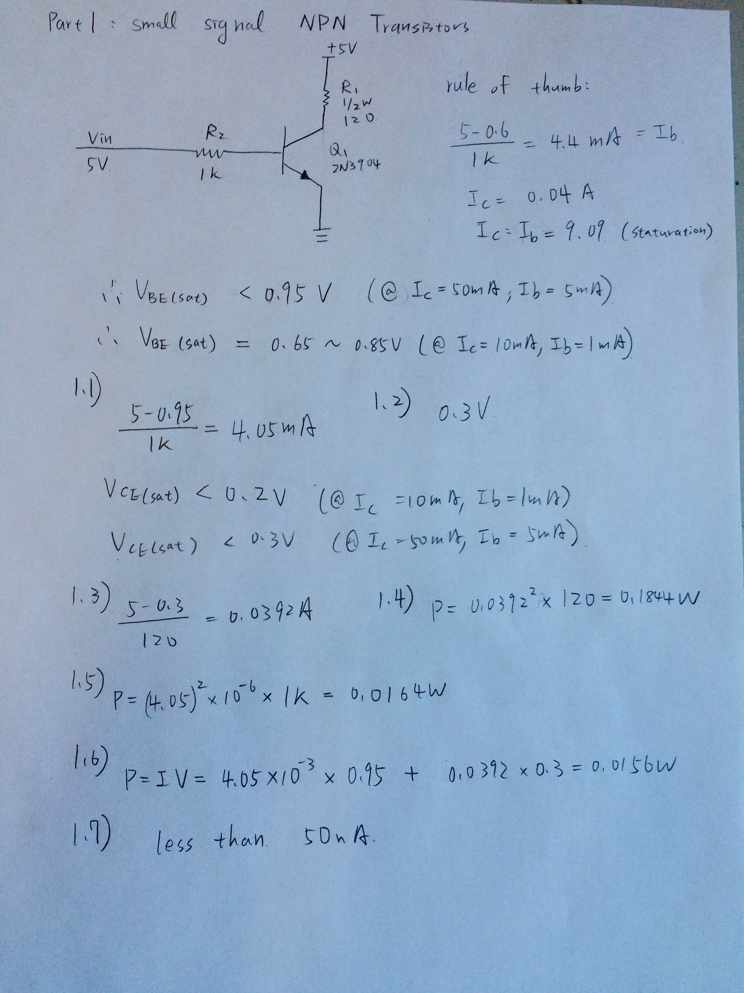

Measured Result

|  |  |  |  |  |
| --- | --- | --- | --- | --- |
| Part1 |  |  |  |  |
| Vin | V1 | V2 | Vb | Vc |
| 0.0056 | 0 | 0 | 0.0068 | 4.99 |
| 0.5 | 0.0007 | 0 | 0.495 | 4.98 |
| 1 | 4.51 | 0.24 | 0.757 | 0.498 |
| 1.5 | 4.87 | 0.724 | 0.777 | 0.159 |
| 2 | 4.9 | 1.23 | 0.785 | 0.131 |
| 2.5 | 4.91 | 1.737 | 0.79 | 0.118 |
| 3 | 4.92 | 2.2 | 0.793 | 0.11 |
| 3.5 | 4.93 | 2.71 | 0.797 | 0.105 |
| 4 | 4.93 | 3.21 | 0.8 | 0.101 |
| 4.5 | 4.94 | 3.7 | 0.803 | 0.098 |
| 4.99 | 4.94 | 4.19 | 0.805 | 0.095 |

Calculated Results

|  |  |  |  |  |  |
| --- | --- | --- | --- | --- | --- |
| IR1 | IR2 | Ic:Ib | PQ1 | Vce | Vbe |
| 0 | 0 | NA | 0 | 5 | 0.0056 |
| 5.9E-06 | 0 | NA | 2.94E-05 | 4.9993 | 0.5 |
| 0.038027 | 0.000245 | 155.2768 | 0.019123 | 0.49 | 0.76 |
| 0.041062 | 0.000739 | 55.58169 | 0.007103 | 0.13 | 0.776 |
| 0.041315 | 0.001255 | 32.91792 | 0.006398 | 0.1 | 0.77 |
| 0.0414 | 0.001772 | 23.35732 | 0.006285 | 0.09 | 0.763 |
| 0.041484 | 0.002245 | 18.47923 | 0.006343 | 0.08 | 0.8 |
| 0.041568 | 0.002765 | 15.03208 | 0.006569 | 0.07 | 0.79 |
| 0.041568 | 0.003276 | 12.69063 | 0.006819 | 0.07 | 0.79 |
| 0.041653 | 0.003776 | 11.03231 | 0.007114 | 0.06 | 0.8 |
| 0.041653 | 0.004276 | 9.742139 | 0.007399 | 0.06 | 0.8 |

Part2: Small Signal PNP Transistors

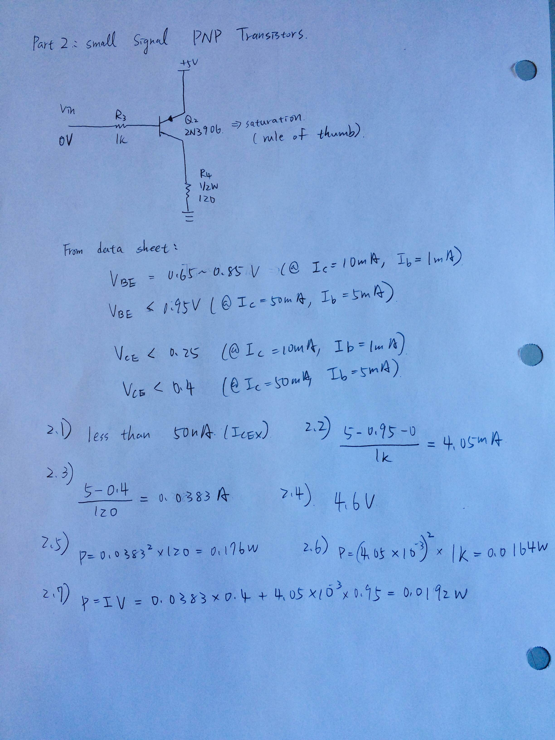

Measured Results

|  |  |  |  |  |
| --- | --- | --- | --- | --- |
| Part2 |  |  |  |  |
| Vin | V3 | V4 | Vb | Vc |
| 0.007 | 4.16 | 4.88 | 4.16 | 4.9 |
| 0.494 | 3.68 | 4.93 | 4.16 | 4.89 |
| 0.989 | 3.17 | 4.93 | 4.16 | 4.89 |
| 1.502 | 2.67 | 4.93 | 4.16 | 4.89 |
| 2 | 2.17 | 4.92 | 4.16 | 4.89 |
| 2.5 | 1.68 | 4.92 | 4.16 | 4.87 |
| 3 | 1.18 | 4.9 | 4.18 | 4.86 |
| 3.51 | 0.69 | 4.87 | 4.19 | 4.83 |
| 4 | 0.23 | 1.8 | 4.48 | 0.07 |
| 4.51 | 0 | 0 | 4.49 | 0 |
| 4.99 | 0 | 0 | 4.98 | 0 |

Calculated Results

|  |  |  |  |  |  |  |  |
| --- | --- | --- | --- | --- | --- | --- | --- |
| Vin | IR3 | IR4 | Ic:Ib | PQ1 | Vce | Vbe | Vbc |
| 0.007 | 0.004244898 | 0.041147 | 9.69321572 | 0.008079 | 0.12 | 0.833 | -0.74 |
| 0.494 | 0.003755102 | 0.041568 | 11.0698182 | 0.005651 | 0.07 | 0.826 | -0.73 |
| 0.989 | 0.003234694 | 0.041568 | 12.8507668 | 0.005271 | 0.07 | 0.841 | -0.73 |
| 1.502 | 0.00272449 | 0.041568 | 15.2572775 | 0.004899 | 0.07 | 0.828 | -0.73 |
| 2 | 0.002214286 | 0.041484 | 18.7347005 | 0.004935 | 0.08 | 0.83 | -0.73 |
| 2.5 | 0.001714286 | 0.041484 | 24.1989882 | 0.004536 | 0.08 | 0.82 | -0.71 |
| 3 | 0.001204082 | 0.041315 | 34.3127447 | 0.00495 | 0.1 | 0.82 | -0.68 |
| 3.51 | 0.000704082 | 0.041062 | 58.3205025 | 0.005789 | 0.13 | 0.8 | -0.64 |
| 4 | 0.000234694 | 0.015177 | 64.6674976 | 0.049602 | 3.2 | 0.77 | 4.41 |
| 4.51 | 0 | 0 | NA | 0 | 5 | 0.49 | 4.49 |
| 4.99 | 0 | 0 | NA | 0 | 5 | 0.01 | 4.98 |

Part3: Small Signal N-Channel MOSFETs

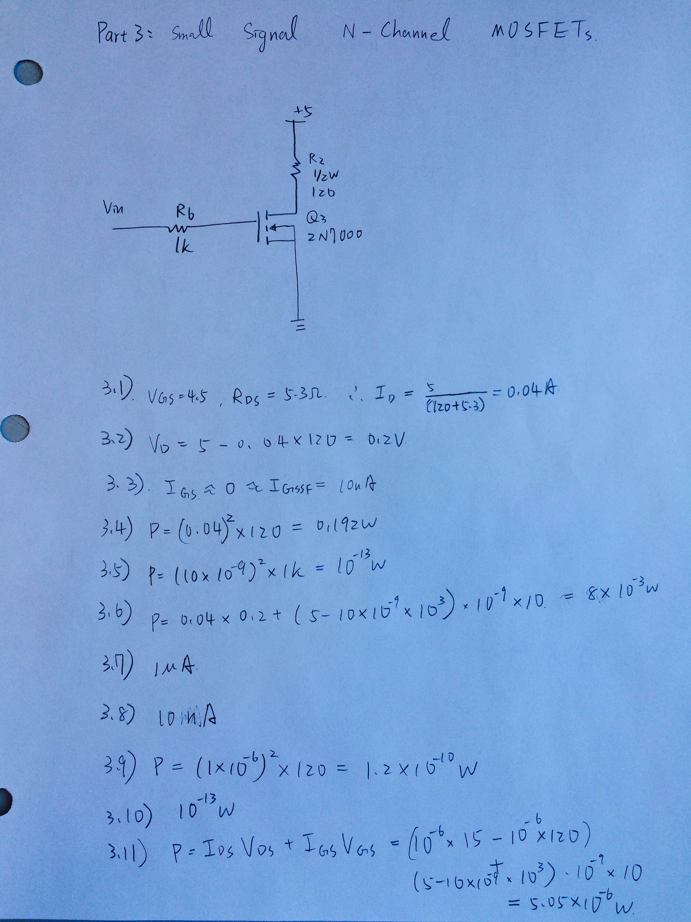

|  |  |  |  |  |
| --- | --- | --- | --- | --- |
| Part3 |  |  |  |  |
| Vin | V6 | V5 | Vg | Vd |
| 0.006 | 0 | 0 | 0.007 | 4.99 |
| 0.506 | 0 | 0 | 0.503 | 4.99 |
| 1.012 | 0 | 0.0007 | 1.01 | 4.98 |
| 1.507 | 0 | 0.7 | 1.5 | 4.29 |
| 1.97 | 0 | 4.74 | 1.97 | 0.29 |
| 2.5 | 0 | 4.84 | 2.5 | 0.19 |
| 2.98 | 0 | 4.87 | 2.98 | 0.17 |
| 3.51 | 0 | 4.88 | 3.5 | 0.15 |
| 3.99 | 0 | 4.89 | 3.98 | 0.15 |
| 4.5 | 0 | 4.89 | 4.5 | 0.14 |
| 4.99 | 0 | 4.89 | 4.97 | 0.14 |

Calculated Results

|  |  |  |  |  |  |
| --- | --- | --- | --- | --- | --- |
| Vin | IR6 | IR5 | Ids:Ig | PQ3 | RDSON |
| 0.006 | 0 | 0 |  | 0 | NA |
| 0.506 | 0 | 0 |  | 0 | NA |
| 1.012 | 0 | 5.9E-06 |  | 2.94E-05 | 843754.3 |
| 1.507 | 0 | 0.005902 |  | 0.02532 | 726.8486 |
| 1.97 | 0 | 0.039966 |  | 0.01159 | 7.256118 |
| 2.5 | 0 | 0.040809 |  | 0.007754 | 4.655785 |
| 2.98 | 0 | 0.041062 |  | 0.006981 | 4.140041 |
| 3.51 | 0 | 0.041147 |  | 0.006172 | 3.645492 |
| 3.99 | 0 | 0.041231 |  | 0.006185 | 3.638037 |
| 4.5 | 0 | 0.041231 |  | 0.005772 | 3.395501 |
| 4.99 | 0 | 0.041231 |  | 0.005772 | 3.395501 |

Part4: NPN Power Transistors

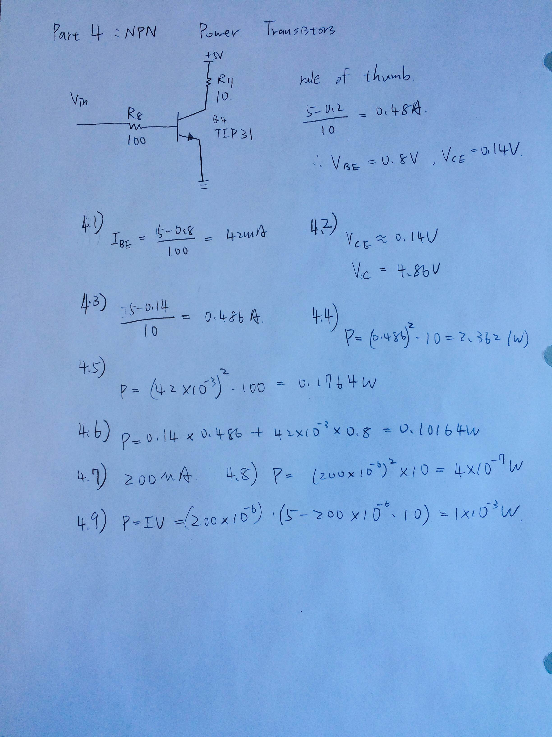

Measured Results

|  |  |  |  |  |
| --- | --- | --- | --- | --- |
| Part4 |  |  |  |  |
| Vin | V8 | V7 | Vb | Vc |
| 0.006 | 0 | 0 | 0.0074 | 4.99 |
| 0.497 | 0 | 0.0009 | 0.5 | 4.98 |
| 1.002 | 0.267 | 3.64 | 0.738 | 1.203 |
| 1.509 | 0.738 | 4.78 | 0.789 | 0.186 |
| 2 | 1.201 | 4.81 | 0.811 | 1.48 |
| 2.5 | 1.7 | 4.83 | 0.825 | 0.134 |
| 3.02 | 2.2 | 4.83 | 0.832 | 0.127 |
| 3.53 | 2.7 | 4.84 | 0.839 | 0.123 |
| 3.99 | 3.16 | 4.84 | 0.844 | 0.12 |
| 4.5 | 3.66 | 4.84 | 0.849 | 0.119 |
| 4.94 | 4.09 | 4.84 | 0.852 | 0.117 |

Calculated Results

|  |  |  |  |  |
| --- | --- | --- | --- | --- |
| Vin | IR8 | IR7 | Ic:Ib | PQ4 |
| 0.006 | 0 | 0 | NA | 0 |
| 0.497 | 0 | 7.96E-05 | NA | 0.000397 |
| 1.002 | 0.002702 | 0.322124 | 119.1979 | 0.389509 |
| 1.509 | 0.00747 | 0.423009 | 56.63045 | 0.084573 |
| 2 | 0.012156 | 0.425664 | 35.01713 | 0.639841 |
| 2.5 | 0.017206 | 0.427434 | 24.84144 | 0.071471 |
| 3.02 | 0.022267 | 0.427434 | 19.19566 | 0.07281 |
| 3.53 | 0.027328 | 0.428319 | 15.67329 | 0.075611 |
| 3.99 | 0.031984 | 0.428319 | 13.39173 | 0.078393 |
| 4.5 | 0.037045 | 0.428319 | 11.56226 | 0.082421 |
| 4.94 | 0.041397 | 0.428319 | 10.34667 | 0.085383 |

Part5: PNP Power Transistors

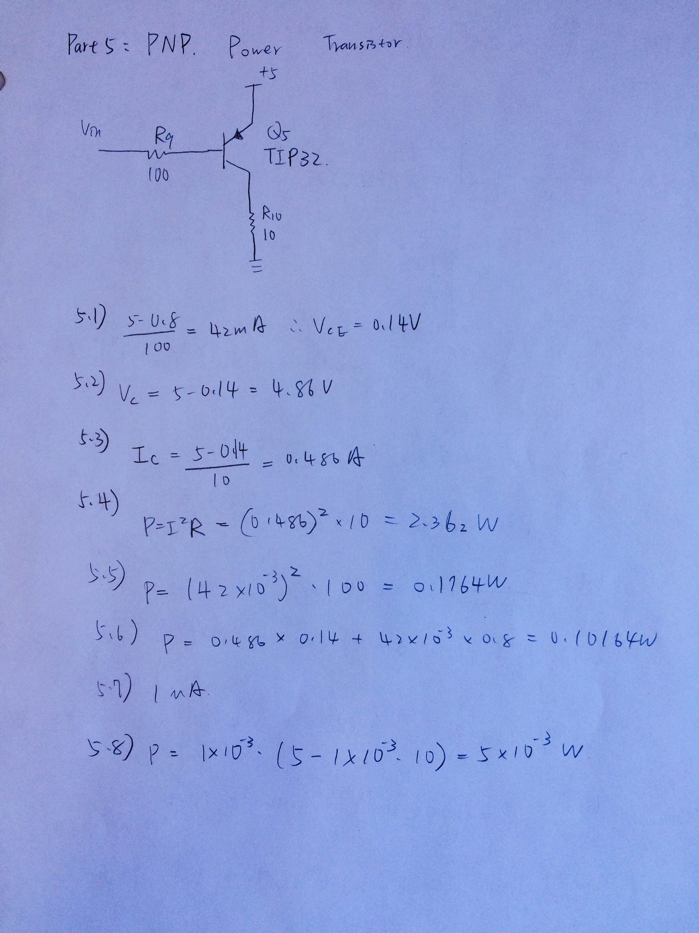

|  |  |  |  |  |
| --- | --- | --- | --- | --- |
| Part5 |  |  |  |  |
| Vin | V9 | V10 | Vb | Vc |
| 0.0707 | 4.05 | 4.76 | 4.13 | 4.8 |
| 0.513 | 3.61 | 4.75 | 4.13 | 4.79 |
| 1.004 | 3.12 | 4.74 | 4.13 | 4.78 |
| 1.498 | 2.64 | 4.73 | 4.14 | 4.77 |
| 1.997 | 2.15 | 4.71 | 4.15 | 4.74 |
| 2.5 | 1.65 | 4.67 | 4.16 | 4.7 |
| 2.97 | 1.2 | 4.58 | 4.18 | 4.67 |
| 3.52 | 0.69 | 3.9 | 4.22 | 3.95 |
| 4.06 | 0.24 | 1.53 | 4.3 | 1.56 |
| 4.52 | 0.0004 | 0.0013 | 4.51 | 0.0078 |
| 5 | 0 | 0 | 4.99 | 0.0007 |
| Vin | IR9 | IR10 | Ic:Ib |  |
| 0.0707 | 0.040992 | 0.421239 | 10.27615 |  |
| 0.513 | 0.036538 | 0.420354 | 11.50442 |  |
| 1.004 | 0.031579 | 0.419469 | 13.28319 |  |
| 1.498 | 0.026721 | 0.418584 | 15.66519 |  |
| 1.997 | 0.021761 | 0.416814 | 19.15406 |  |
| 2.5 | 0.0167 | 0.413274 | 24.74637 |  |
| 2.97 | 0.012146 | 0.40531 | 33.3705 |  |
| 3.52 | 0.006984 | 0.345133 | 49.41901 |  |
| 4.06 | 0.002429 | 0.135398 | 55.73894 |  |
| 4.52 | 4.05E-06 | 0.000115 | 28.41593 |  |
| 5 | 0 | 0 | NA |  |

5.7) 200*10-6 A => CORRECTION OF PreLab1

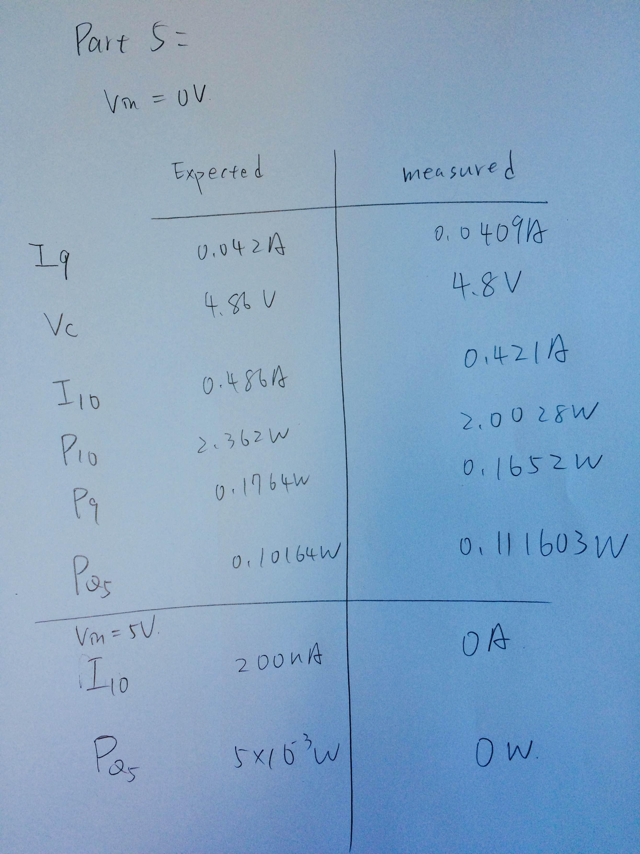\

Part6: P-Channel Power MOSFETs

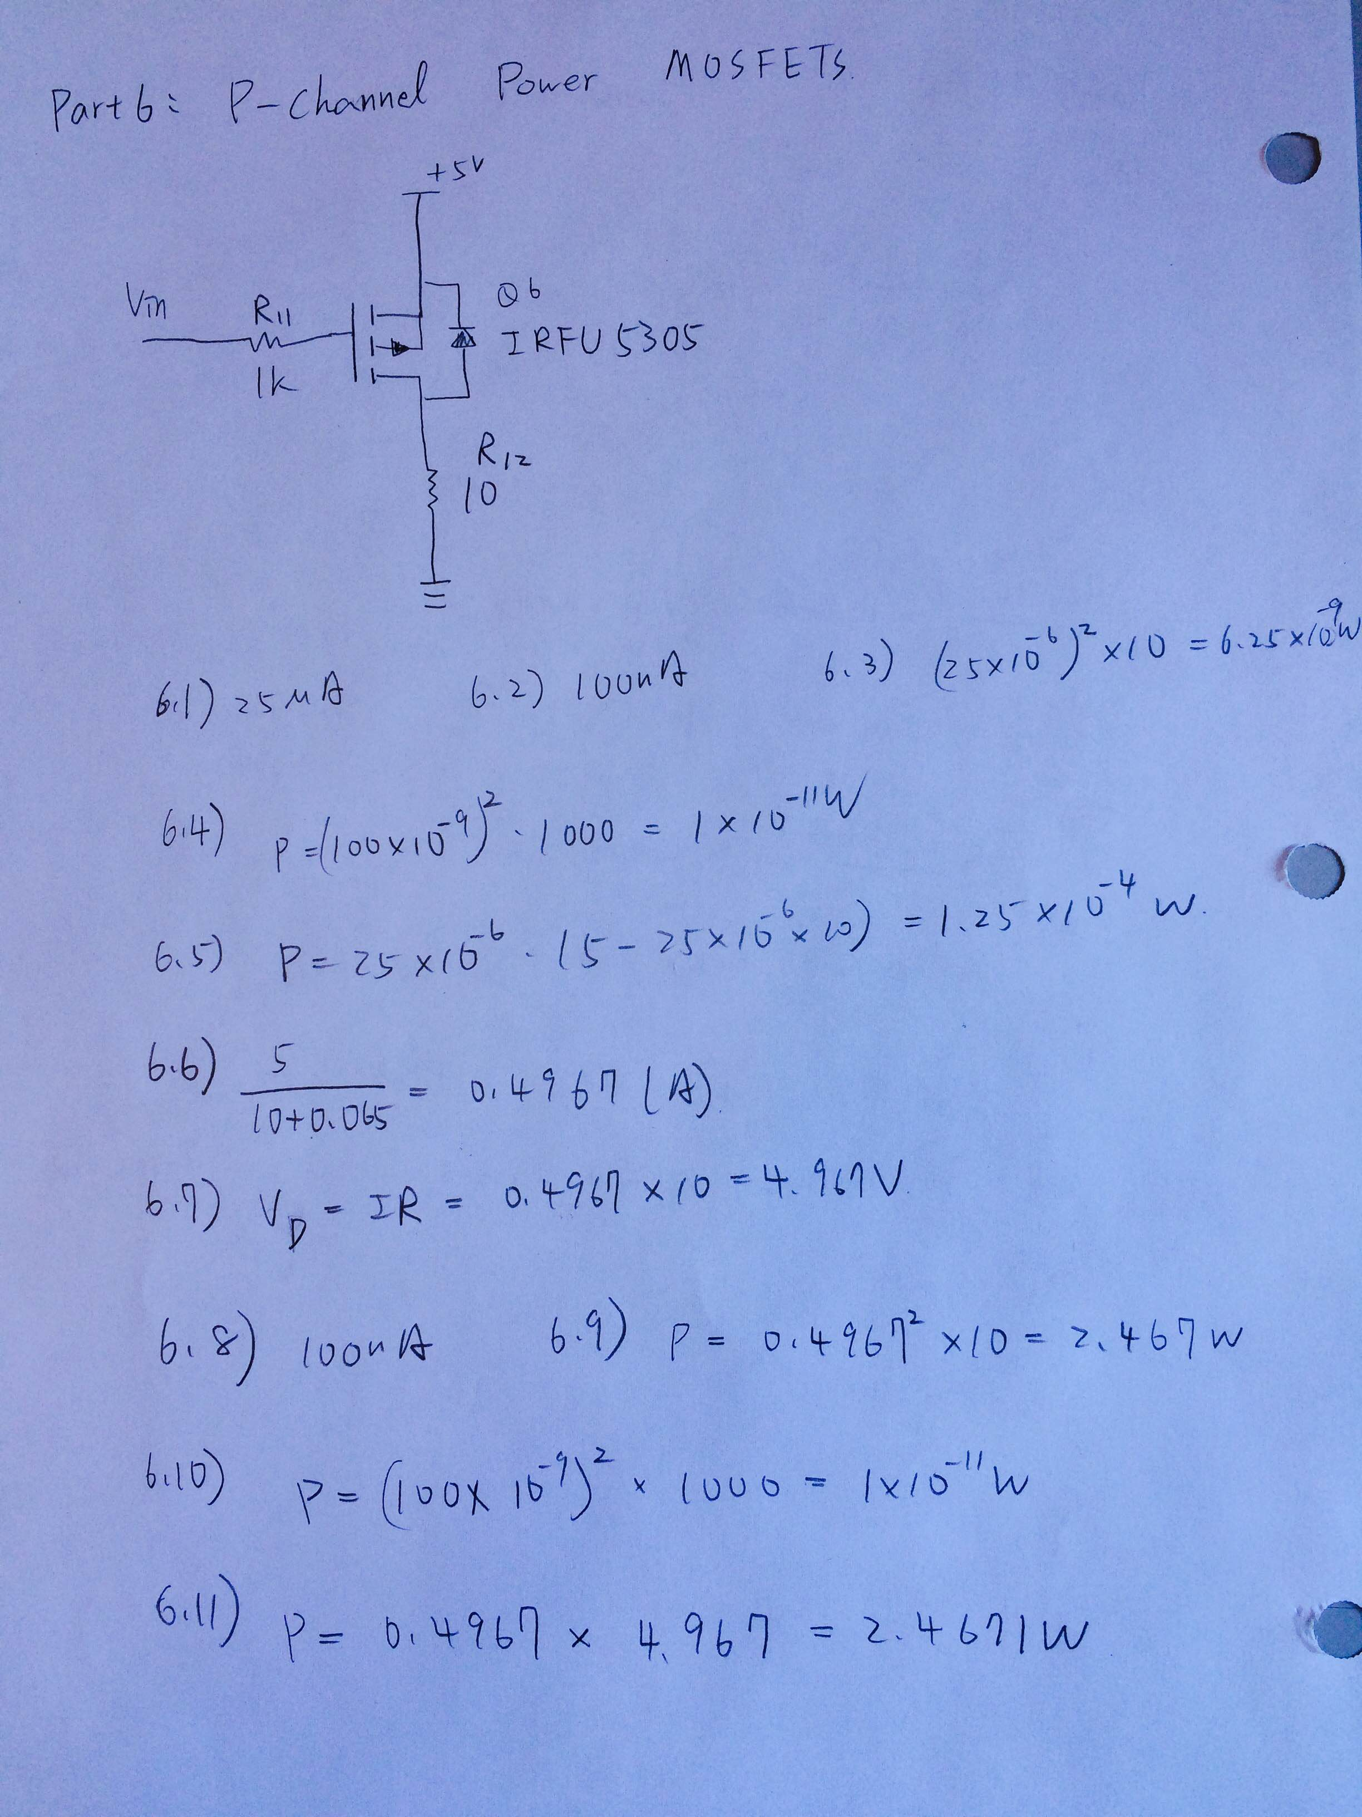

|  |  |  |  |  |
| --- | --- | --- | --- | --- |
| Part6 |  |  |  |  |
| Vin | V11 | V12 | Vg | Vd |
| 0.06 | 0 | 4.86 | 0.073 | 4.86 |
| 0.501 | 0 | 4.74 | 0.51 | 4.76 |
| 0.999 | 0 | 2.95 | 1.01 | 2.94 |
| 1.51 | 0 | 0.14 | 1.5 | 0.13 |
| 2.02 | 0 | 0.0008 | 2.01 | 0.007 |
| 2.51 | 0 | 0 | 2.51 | 0 |
| 2.99 | 0 | 0 | 2.98 | 0.006 |
| 3.52 | 0 | 0 | 3.52 | 0.007 |
| 4.03 | 0 | 0 | 4.01 | 0.0068 |
| 4.5 | 0 | 0 | 4.49 | 0.007 |
| 5 | 0 | 0 | 4.98 | 0.0067 |
| Vin | IR11 | IR12 | Ids:Ig | PQ6 | RDSON |
| 0.06 | 0 | 0.430088 |  | 0.6804 | 0.325514 |
| 0.501 | 0 | 0.419469 |  | 1.1376 | 0.572152 |
| 0.999 | 0 | 0.261062 |  | 6.077 | 7.890847 |
| 1.51 | 0 | 0.012389 |  | 0.6818 | 393.0786 |
| 2.02 | 0 | 7.08E-05 |  | 0.003994 | 70526.13 |
| 2.51 | 0 | 0 |  | 0 | #DIV/0! |
| 2.99 | 0 | 0 |  | 0 | #DIV/0! |
| 3.52 | 0 | 0 |  | 0 | #DIV/0! |
| 4.03 | 0 | 0 |  | 0 | #DIV/0! |
| 4.5 | 0 | 0 |  | 0 | #DIV/0! |
| 5 | 0 | 0 |  | 0 | #DIV/0! |

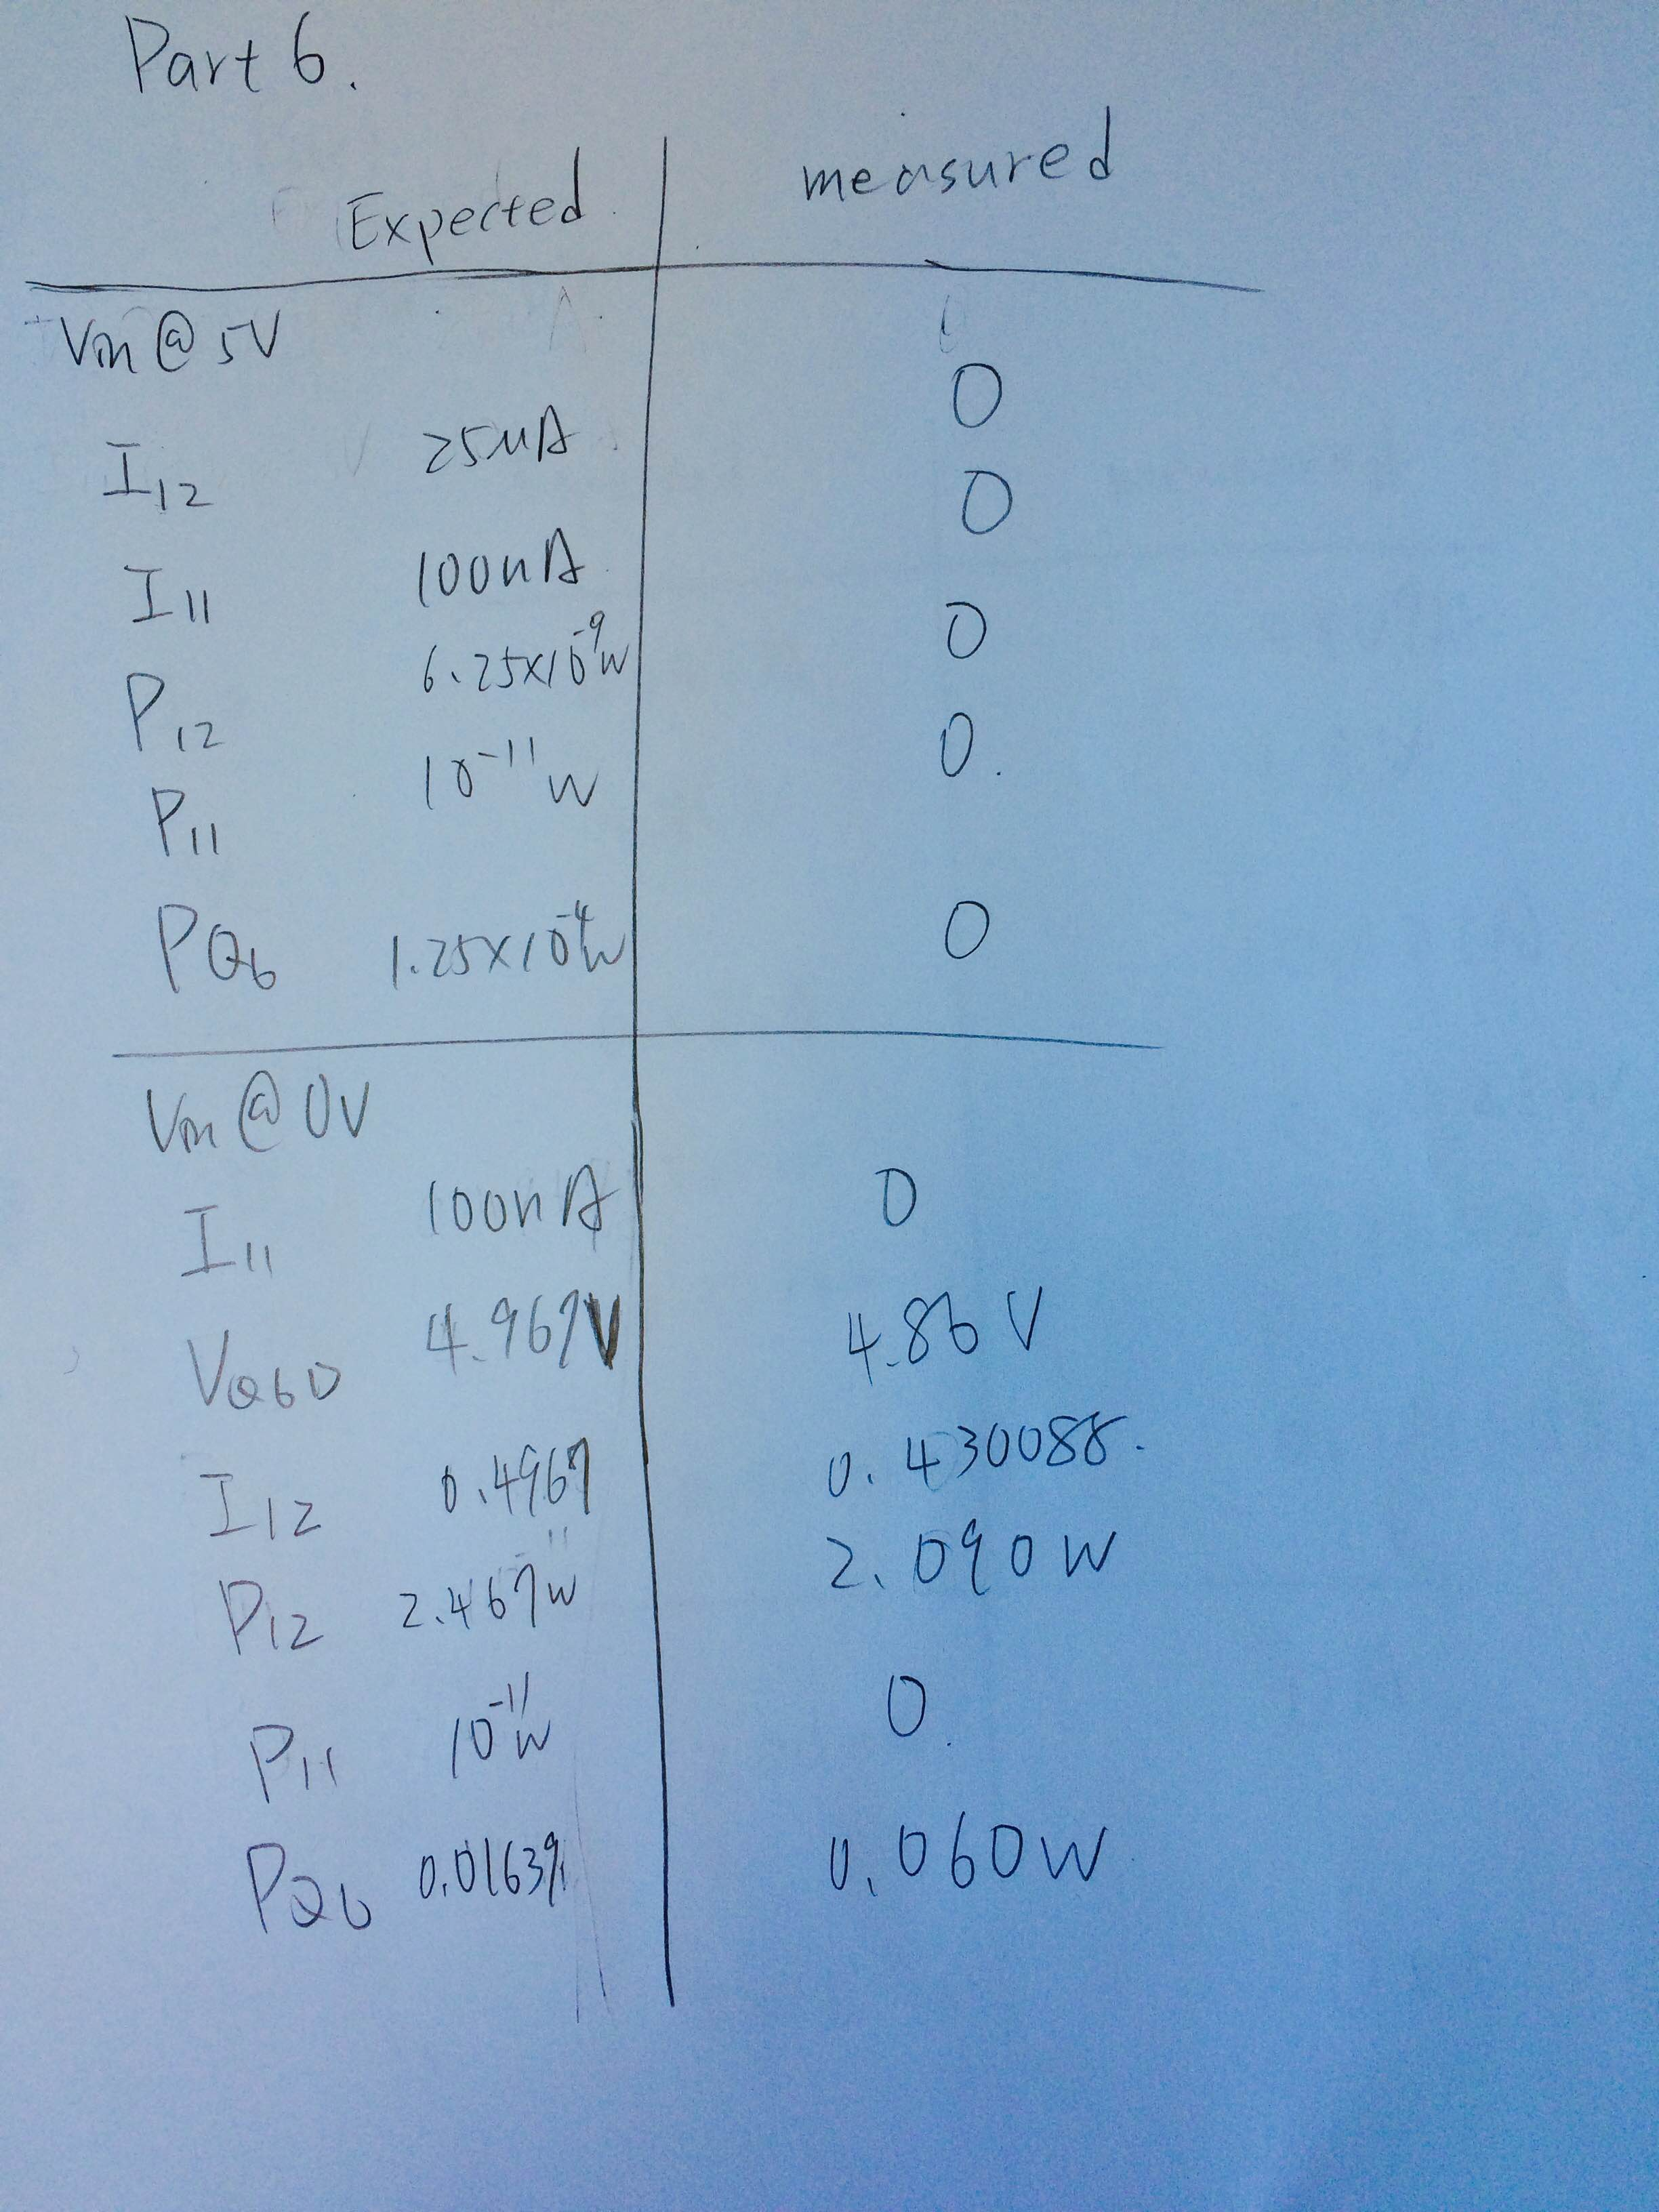\

Part7: N-Channel Power MOSFETs

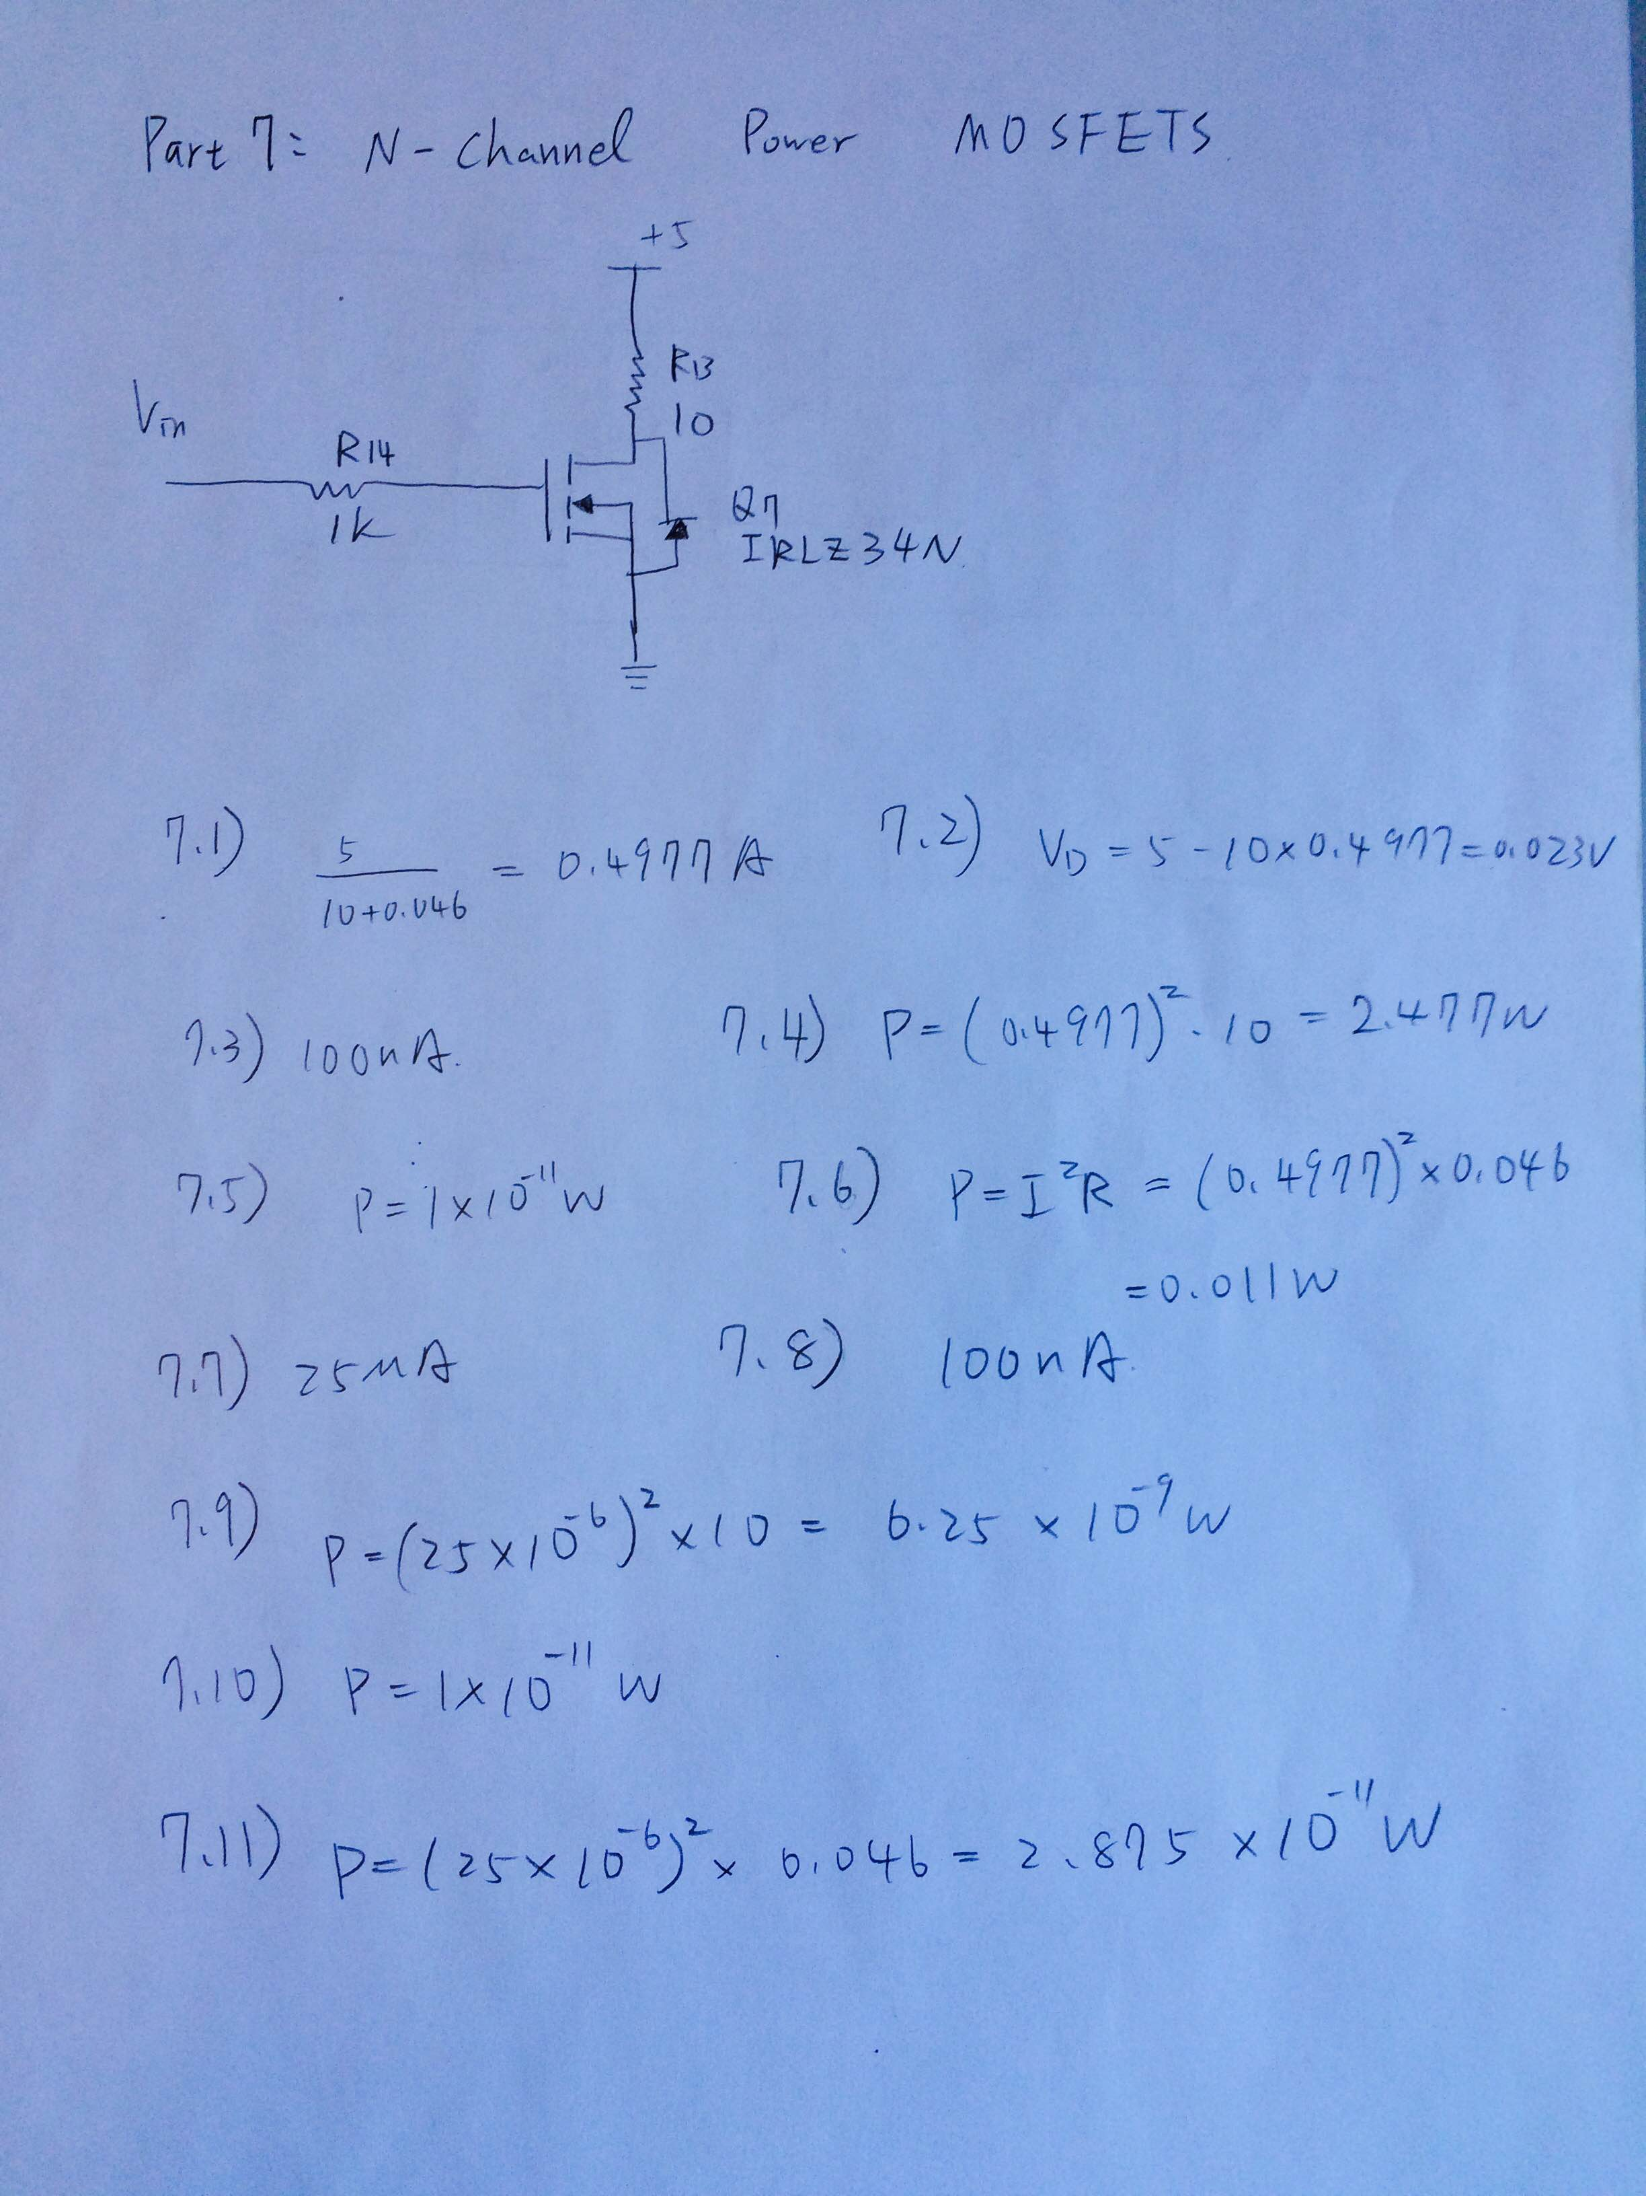

Measured Results

|  |  |  |  |  |
| --- | --- | --- | --- | --- |
| Part7 |  |  |  |  |
| Vin | V14 | V13 | Vg | Vd |
| 0.0062 | 0 | 0 | 0.0073 | 5 |
| 0.498 | 0 | 0 | 0.49 | 4.9 |
| 1.001 | 0 | 0 | 1 | 4.99 |
| 1.502 | 0 | 0.0017 | 1.5 | 4.9 |
| 2.02 | 0 | 2.19 | 2.01 | 2.62 |
| 2.5 | 0 | 4.89 | 2.5 | 0.086 |
| 3 | 0 | 4.9 | 2.99 | 0.109 |
| 3.49 | 0 | 4.9 | 3.49 | 0.081 |
| 4.01 | 0 | 4.91 | 4.02 | 0.0966 |
| 4.48 | 0 | 4.91 | 4.48 | 0.08 |
| 4.94 | 0 | 4.91 | 4.95 | 0.07 |

Calculated Results

|  |  |  |  |  |  |
| --- | --- | --- | --- | --- | --- |
| Vin | IR14 | IR13 | Ids:Ig | PQ7 | RDSON |
| 0.0062 | 0 | 0 |  | 0 | #DIV/0! |
| 0.498 | 0 | 0 |  | 0 | #DIV/0! |
| 1.001 | 0 | 0 |  | 0 | #DIV/0! |
| 1.502 | 0 | 0.00015 |  | 0.000737 | 32570.59 |
| 2.02 | 0 | 0.193805 |  | 0.50777 | 13.51872 |
| 2.5 | 0 | 0.432743 |  | 0.037216 | 0.198732 |
| 3 | 0 | 0.433628 |  | 0.047265 | 0.251367 |
| 3.49 | 0 | 0.433628 |  | 0.035124 | 0.186796 |
| 4.01 | 0 | 0.434513 |  | 0.041974 | 0.222318 |
| 4.48 | 0 | 0.434513 |  | 0.034761 | 0.184114 |
| 4.94 | 0 | 0.434513 |  | 0.030416 | 0.1611 |

Part8: NPN Darlington Transistors

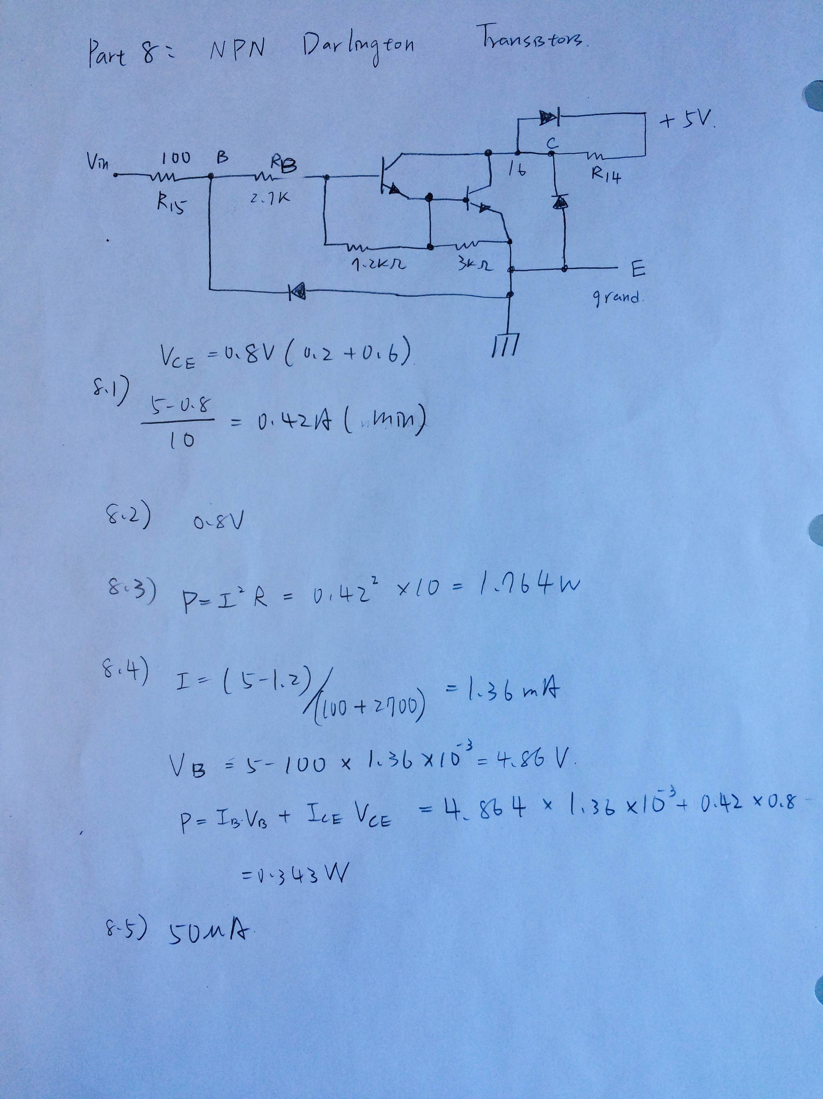

Experimental results

8.1) When Vin = 5V, how much current flow in resistor R14?

V14 = 3.8V, I14 = 0.33628A, V15 = 0.76V

8.2) When Vin = 5V, how much voltage at pin16?

1.17V

8.3) When Vin = 5V, power dissipation in R14?

1.2778518W

8.4) When Vin is at 5V, power dissipation in ULN2003

(0.76/98.8)*4.24+0.33628*1.17 = 0.426W

8.5) When Vin is at 0V, what current do you expect to flow in resistor R14?

50*10-6 A

Measured results: 1.76*10-3A

|  |  |  |  |
| --- | --- | --- | --- |
|  | Expected |  | Measured |
| I14 | 0.42A |  | 0.33628A |
|  |  |  |  |
| Vpin16 | 0.8V |  | 1.17V |
|  |  |  |  |
| P14 | 1.764W |  | 1.277W |
|  |  |  |  |
| PULN2003 | 0.343W |  | 0.426W |
|  |  |  |  |
| I14 @ Vin=0V | 50*10-6A |  | 1.76*10-3A |